**Step-by-Step Methodology**

**1. Project Overview**

Our project aims to monitor baby’s movements and check the situation of baby in terms of weather they are under the safety or not. There are a lot of sensors to detect baby’s weight, cries, and provides a live video for parents via a web user interface. Plus, there is a electricity leakage detection for protecting baby. The intention of this project is providing a comprehensive care.

**2. Subsystems Design**

There are lots of subsystems for the project, and each system is responsible for the corresponding work. Therefore, it can be divided as two parts, hardware and software, coming along with their own functionalities:

1. **Sensor Subsystem (Hardware)**

• **Pressure Sensor**:

• **Functionality**: For the pressure sensor, it consistently detects the weights of baby. There will be an alert, if the pressure sensor founds an unnormal changes of weight, which may means that baby was out of cradle or trying get out of cradle potentially.

• **Interdependence**: It provides the current weights for Raspberry Pi as a processable resource.

• **Sound Sensor**:

• **Functionality**: As for the sound sensor, it can detect the sound level to make a judgement of baby’s status. If the baby is crying or scream, there will be some works following the unnormal sounds , such as playing a soothing song, swinging the cradle, and sending a notification to the parents.

• **Interdependence**: It provides the current sounds level for Raspberry Pi for the following solutions.

• **Camera Sensor (NoIR)**:

• **Functionality**: In this part, the camera sensor will record how was baby doing. Also, it allows parents to watch the baby remotely via a web user interface.

• **Interdependence**: Streams video data to the web interface via the Raspberry Pi.

• **Temperature Sensor:**

• **Functionality**: In this part, the temperature sensor will record baby’s body temperature. Also, it allows parents to watch the baby’s body temperature remotely via a web user interface.

• **Interdependence**: Data to the web interface via the Raspberry Pi.

2. **Processing Subsystem (Hardware/Software)**

• **Raspberry Pi**:

• **Functionality**: Acts as the central processing unit, handling all sensor data, processing it, and making decisions based on the inputs. It also manages the web interface and alerts.

• **Interdependence**: Collects data from all sensors, processes it, and interacts with the web server to provide a user interface and send notifications.

3. **Communication Subsystem (Hardware/Software)**

• **Wi-Fi Module**:

• **Functionality**: Provides wireless connectivity, allowing the Raspberry Pi to communicate with the web server and send notifications via email or SMS.

• **Interdependence**: Ensures that the system remains connected to the internet for real-time monitoring and notifications.

4. **Alert and Notification Subsystem (Software)**

• **Email/SMS Notifications**:

• **Functionality**: It will send alerts to parents, if there is something not well such as when baby is crying, screaming.

• **Interdependence**: Receives triggers from the Raspberry Pi based on sensor data.

5. **Data Logging and Monitoring Subsystem (Software)**

• **Functionality**: Logs sensor data, including video, sound levels, and movement data, for analysis and review.

• **Interdependence**: Works with the Raspberry Pi to store data locally or in the cloud, accessible through the web interface.

6. **Power Supply Subsystem (Hardware)**

• **Functionality**: Provides power to the entire system. Currently, there is no backup system, so the system relies on a stable power source.

• **Interdependence**: Ensures that all subsystems remain operational.

7. **User Interface Subsystem (Software)**

• **Web Interface**:

• **Front End**: Built using HTML, CSS, and JavaScript, this interface allows parents to monitor the baby in real-time and receive alerts.

• **Back End**: Developed using Flask, the back end handles data processing, communication with the Raspberry Pi, and managing the database.

• **Interdependence**: Provides a portal for parents to interact with the system, view live video, and receive notifications.

8. **Electricity Leakage Detection Subsystem (Hardware/Software)**

• **Functionality**: Detects any potential electrical leakage in the cradle’s power system to protect the baby from harm. Although specific details of this subsystem are not provided, it would typically involve sensors that monitor the electrical system and trigger an alert if leakage is detected.

• **Interdependence**: Works independently to monitor electrical safety but sends alerts through the same system used for baby monitoring.

**Block Diagram of the Complete System**

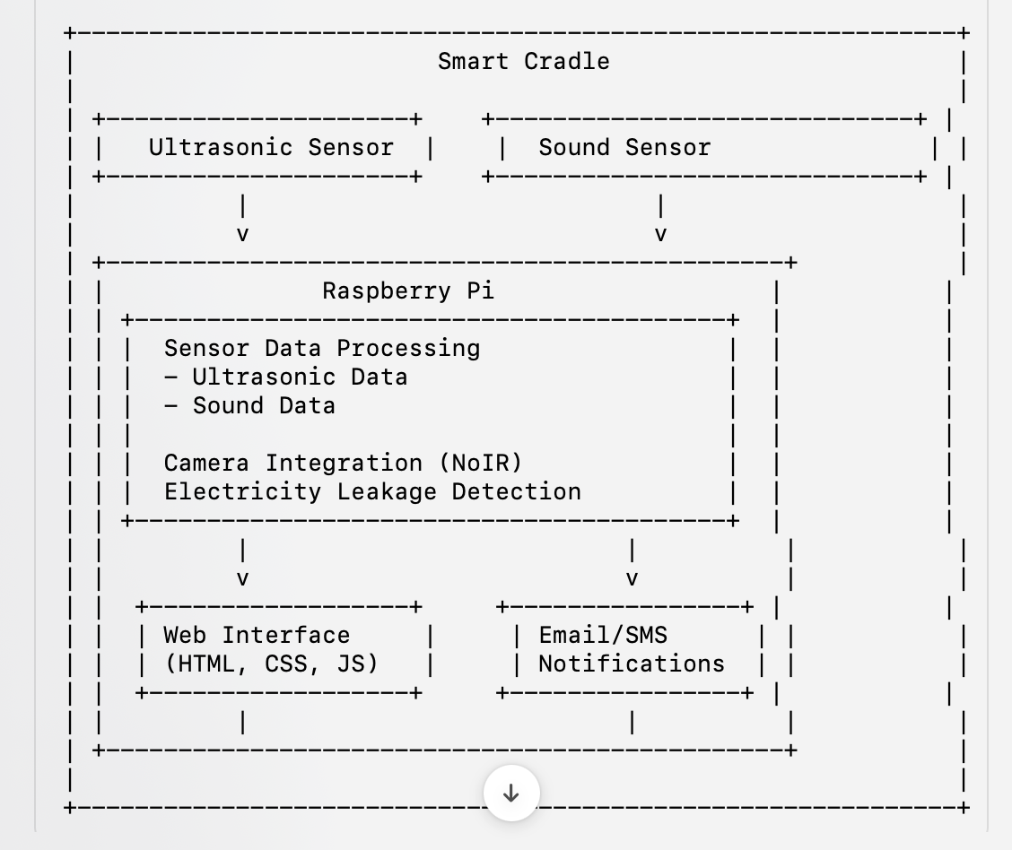

**Subsystems Functionalities and Interdependencies**

1. **Sensor Subsystem**:

• **Hardware**: Ultrasonic sensor, sound sensor, and camera sensor.

• **Functionality**: Collects data on the baby’s position, movements, and sounds.

• **Interdependence**: Sends data to the Raspberry Pi for processing.

2. **Processing Subsystem**:

• **Hardware/Software**: Raspberry Pi running data processing algorithms.

• **Functionality**: Analyzes sensor data, controls the camera, manages the web interface, and triggers alerts.

• **Interdependence**: Receives data from sensors, processes it, and interfaces with the communication and user interface subsystems.

3. **Communication Subsystem**:

• **Hardware/Software**: Wi-Fi module.

• **Functionality**: Ensures connectivity for remote monitoring and notifications.

• **Interdependence**: Connects the Raspberry Pi to the internet for real-time monitoring and alerting.

4. **Alert and Notification Subsystem**:

• **Software**: Email/SMS notifications.

• **Functionality**: Sends real-time alerts to parents based on the data received from the Raspberry Pi.

• **Interdependence**: Triggered by the Raspberry Pi based on sensor inputs.

5. **Data Logging and Monitoring Subsystem**:

• **Software**: Data logging application.

• **Functionality**: Records sensor data for analysis and review.

• **Interdependence**: Works with the Raspberry Pi to log data and provide access via the web interface.

6. **Power Supply Subsystem**:

• **Hardware**: Main power supply.

• **Functionality**: Powers the entire system.

• **Interdependence**: Powers all hardware components, ensuring system operation.

7. **User Interface Subsystem**:

• **Software**: Web interface (HTML, CSS, JS).

• **Functionality**: Allows parents to interact with the system, view live video, and receive alerts.

• **Interdependence**: Displays data processed by the Raspberry Pi and allows user interaction.

8. **Electricity Leakage Detection Subsystem**:

• **Hardware/Software**: Leakage detection sensors and alert system.

• **Functionality**: Monitors electrical safety and triggers alerts if leakage is detected.

• **Interdependence**: Works independently but sends alerts through the same notification system.

**Problem to be Solved**

**Individual Problems:**

1. **Lack of Constant Monitoring**:

• There are lots of new parents always being warried about that they can not take care their baby all the time, especially during they are working. Therefore, it can result in some of problems, for example, high stress level and feeling anxious. Similarly, the baby’s safety is also a very important factor that should be concerned about.

2. **Risk of Accidents**:

• As for now, traditional cradles do not have mechanisms to avoid potential problems, for example, when the baby attempts to climb out of cradle or get into an unsafe position. This may lead a very dangerous hurt for baby’s safety.

3. **Delayed Response to Baby’s Distress**:

• Parents might not quickly know when their baby is in distress without a live video, which may result in some of problems like baby will feel discomfortable for a long time.

4. **Electrical Safety Concerns**:

• Electrical devices used in and around the cradle can pose a hazard if there is any leakage or malfunction, potentially putting the baby at risk.

**Social Problems:**

1. **Increased Parental Stress and Mental Health Issues**:

• Constantly worrying about the baby's safety can cause great psychological pressure on new parents, such as postpartum depression and anxiety. This will not only affect their physical and mental health, but also make them unable to do their best to take care of the baby.

2. **Limited Access to Reliable Childcare Solutions**:

• Many parents, especially those with limited resources, do not have access to advanced baby monitoring technology, which makes it difficult for them to have peace of mind and better ensure their baby's safety.

3. **High Infant Mortality and Morbidity Rates**:

• In many communities, accidents that occur while babies sleep, such as suffocation or falls, often lead to death or illness in infants, and traditional monitoring methods often cannot prevent these situations.

4. **Societal Pressure on Parenting**:

• Society places high expectations on parents to keep their children safe at all times. Parents who fail to meet these expectations because they lack the tools to do so may feel overwhelmed and feel like they are not doing enough.

**Benefits of Our Solution**

**Individual Benefits:**

1. **Continuous Monitoring and Alerts**:

• Smart caradle can continuously monitor the baby’s movements, sounds and environment, ensuring that parents are immediately alerted to any potential danger or discomfort to the baby so they can respond quickly.

2. **Enhanced Safety and Accident Prevention**:

• Through sensors, the smart cradle can detect unsafe movements of the baby, such as getting close to the edge of the cradle or trying to climb out, and help prevent it in advance. This greatly reduces the risk of the baby falling or suffocating.

3. **Reduced Parental Anxiety**:

• Smart cradle reduce anxiety and stress for parents by providing real-time data and alerts, letting them know their child is being monitored and safe. This also helps improve parents’ mental health.

4. **Automatic Soothing Mechanisms**:

• When the baby cries or feels uncomfortable, the bassinet can automatically rock or play a lullaby to comfort the baby, which is especially useful at night and helps parents take care of the baby's needs more easily.

5. **Electrical Safety Assurance**:

• The inclusion of an electricity leakage detection system provides an additional layer of safety, ensuring that any electrical hazards are detected and mitigated before they can cause harm.

**Social Benefits:**

1. **Improved Mental Health for Parents**:

• Smart cradle can alleviate some of the stress of caring for a baby, helping parents achieve better mental health and reducing the risk of parenting-related anxiety and depression.

2. **Accessible and Affordable Childcare Technology**:

• As smart cradle technology becomes more common, it will become an affordable and accessible option for more families, giving more people access to advanced baby monitoring technology.

3. **Reduction in Infant Mortality and Morbidity**:

• The smart cradle can help reduce the rates of infant mortality and morbidity related to sleep accidents, contributing to better overall public health outcomes.

4. **Support for Modern Parenting**:

• The smart cradle helps modern parents by using technology in baby care, making it easier for them to meet society’s high expectations without compromising their well-being.

5. **Community and Social Impact**:

• Widespread use of smart cradles could change how we approach baby care, highlighting the role of technology in keeping children safe and possibly setting new standards for childcare practices.

**Impact**

**Individual Impact:**

• **Peace of Mind for Parents**: Smart cradle give parents peace of mind that their baby is safe even when they are not around. This peace of mind allows parents to focus on other things and rest better, knowing that their baby is being well taken care of.

• **Better Sleep Quality**: The smart cradle's automatic soothing function and real-time reminders allow parents and babies to sleep better and develop a healthier schedule and lifestyle.

**Social Impact:**

• **Enhanced Child Safety Standards**: Smart cradles can set new standards for child safety in the home, promote widespread use of similar technologies, and improve overall infant care safety.

• **Contribution to Public Health**: By reducing the risk of accidents and improving parental mental health, smart cradles can help improve public health, especially in communities that currently lack advanced parenting solutions.

• **Empowerment of Parents**: Smart cradles empower parents through technology, making it easier for them to balance the demands of modern life while keeping their children safe and healthy. This support can make parents more confident and capable, which benefits society as a whole.

**Existing Solutions**

Smart baby monitoring systems have become increasingly essential in modern parenting. With the help of IoT technologies to ensure the safety and well-being of infants. These systems typically involve sensors, cameras, and mobile applications to monitor the baby’s environment and activities.

## **A Smart Baby Cradle Based on IoT**

This paper discusses the development of a smart cradle that includes live monitoring through a web camera, addressing the problem of sudden death due to falling from the cradle. The proposed solution aims to enhance the safety of babies through IoT technology.

A Smart Baby Cradle Based on IoT, Alshewani, S. A., & Eassa, F. E., 2020. [Online]. Available: https://www.academia.edu/download/63998973/V9I7202018.pdf. [Accessed 24 August 2024].

## **Application of IoT in Different Aspects of Child Care: Literature Review and Classification**

This review article classifies the different applications of IoT in child care, including innovations in smart cradles and cribs with external web cameras for continuous monitoring.

Application of IoT in Different Aspects of Child Care: Literature Review and Classification, Boruah, K., & Pathak, M. K., 2021. [Online]. Available: https://www.researchgate.net/profile/Kuntala-Boruah/publication/354123249_Application_of_IoT_in_Different_Aspects_of_Child_Care_Literature_Review_and_Classification/links/6267c583ee24725b3ec7f44d/Application-of-IoT-in-Different-Aspects-of-Child-Care-Literature-Review-and-Classification.pdf. [Accessed 24 August 2024].

## **IoT-based Smart Baby Monitoring**

This study proposes an IoT-based smart baby monitoring system that includes a webcam fixed in the cradle to provide real-time monitoring and alerting.

IoT-based Smart Baby Monitoring, Visvesvaran, C., Nishanth, S., & Sudha, R., 2021. [Online]. Available: https://ieeexplore.ieee.org/abstract/document/9532997/. [Accessed 24 August 2024].

## **A Real-Time Internet Of Things (IoT) Based Affective Framework for Monitoring Emotions in Infants**

This paper explores a real-time IoT-based system for monitoring infant emotions and movements, aiming to prevent potential hazards through smart cradle technology.

A Real-Time Internet Of Things (IoT) Based Affective Framework for Monitoring Emotions in Infants, Sallah, A., 2020. [Online]. Available: https://scholarworks.uttyler.edu/cgi/viewcontent.cgi?article=1047&context=ee_grad. [Accessed 24 August 2024].

## **IoT-BBMS: Internet of Things-based Baby Monitoring System for Smart Cradle**

This paper presents a comprehensive IoT-based baby monitoring system designed to prevent falls and ensure the baby’s safety through continuous monitoring.

IoT-BBMS: Internet of Things-based Baby Monitoring System for Smart Cradle, Jabbar, W. A., Shang, H. K., & Hamid, S. N. I. S., 2019. [Online]. Available: https://ieeexplore.ieee.org/abstract/document/8760478/. [Accessed 24 August 2024].

## Existing features in Market for Smart Baby Monitoring Systems

In the current market, several smart baby monitoring systems come equipped with a variety of features. These common features include:

* Bouncing: Automated cradle movement to soothe the baby.
* Video Monitoring (Monitoring RPM): Some systems offer real-time video monitoring, with some also monitoring the cradle's rocking speed (RPM).
* Audio Features: Two-way audio communication allows parents to speak to and hear their baby remotely. Also baby is able to hear music.
* Sleep Analytics: Advanced systems track the baby’s sleep patterns and provide insights to help optimize the baby’s rest.
* White Noise: Integrated white noise generators help babies to sleep more soundly by masking background noise.